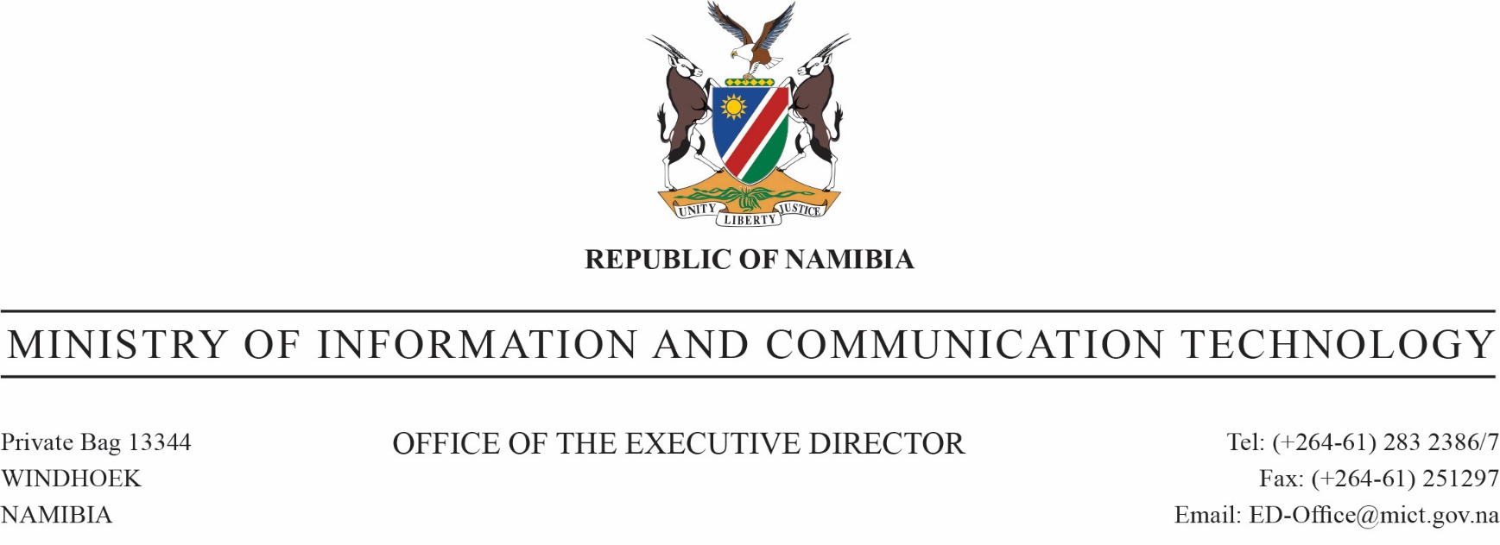

**REPUBLIC OF NAMIBIA**

MINISTRY OF HEALTH AND SOCIAL SERVICES

OFFICE OF THE EXECUTIVE DIRECTOR

Ministerial Building Tel: No: 061 -2032019

Harvey Street Fax No: 061-304 145

Private Bag 13198 PA.ED@mhss.gov.na

Windhoek

Ref:13/2/1

Enquiries: Seija Nakamhela (Chief Pharmacist-CMS) Date: 28 September 2022

**CENTRAL MEDICAL STORES**

**REF: CMS-EP-2022-45**

**Attention: All Suppliers**

**Request for Bids to supply and deliver**

**Contraceptives for Central Medical Stores**

The Ministry of Health and Social Services (MoHSS), through its Central Medical Store (CMS), is seeking to buy contraceptives with the following technical requirements:

|  |  |  |  |  |
| --- | --- | --- | --- | --- |
| **ITEM NO** | **STOCK CODE** | **DESCRIPTION** | **PACK SIZE** | **QTY REQUIRED** |
|  | 0510360 | ETONOGESTREL 68MG INPLANT (IMPLANON NXT) | 1 | 14,000 |
|  | 0510375 | LEVONORG. 150MCG + ETHINYLOES. 30MCG TABS (NORDETTE) | 28 | 140,000 |
|  | 0510365 | NORETHISTERONE 0.35MG TABS (MICRO-NOVUM) | 28 | 110,000 |
|  | 0210622 | MEDROXYPROGESTERONE 150MG/ML INJ | 1 | 180,000 |

**Terms and conditions**

1. All anti-retrovirals, anti-TB, and vaccines should be WHO pre-qualified
2. Only manufactures or dealers in **Pharmaceuticals** who are legally registered and have valid manufacturing or trading license(s) in the republic of Namibia or otherwise legally authorized in the country of exportation of the items specified in the request may submit their offer(s).
3. Suppliers must ensure that the product to be supplied is in full compliance with the Medicines and Related Substance Control Act, 2003 (Act No. 13 of 2003), before delivery to CMS. CMS will not accept any item not in compliance with the said Act. And they should ensure that they have a valid GMP Certificate.
4. To be eligible to participate in this emergency procurement, you should please tick below, to indicate whether each of the following document is attached:

|  |  |  |
| --- | --- | --- |
|  | **Mandatory Document Name / Title** | **Please tick** |
| 1 | **Certified or Original valid Certificate of Good Standing for Procurement Purposes**, issued by the Ministry of Finance: Inland Revenue. |  |
| 2 | **Certified copy of a valid Affirmative Action Compliance Certificate** (issued in terms of Section 42 of the Affirmative Action (Employment) Act 29 of 1998, as amended); or **Letter from the Employment Equity Commission** (letter should be on letterhead, stamped and signed by the EEC). |  |
| 3 | **Certified or Original Certificate of valid Good Standing with the Social Security Commission** that is valid on the date of closing (validity of 30 day) |  |
| 4 | **Certified Copy of the Close Corporation Certificate** (issued in terms of Act 26 of 1988) or **Founding** **Statement or any other Company Registration Certificate.** These Certificates should clearly indicate the goods / services that the Supplier is registered to render. Only clinical and/or medical registered distributors will be considered. **(Ownership should be clearly indicated, as section 67 (2) of the Procurement Act of 2015 will be used if companies are colluding).** |  |
| 5 | **Certified Copy of a valid registration certificate for a Pharmaceutical Distributor Facility from the Health Professional Council of Namibia.** |  |
| 6 | **Certified Copy of a valid Maintenance of registration document for a Pharmaceutical Distributor Facility from the Health Professional Council of Namibia.** |  |
| 7 | **Certified copy of a valid import permit, from the Namibia Medicines Regulatory council (NMRC).** |  |

1. Delivery of the Goods shall be made by the Supplier directly to the CMS in Windhoek, and exclusively contracted as “DDP CMS, Windhoek”.
2. CMS will select its supplier of the listed product, or part thereof, by choosing the response to this solicitation that offers the listed products or part thereof. CMS will notify the successful bidder after completion of the selection process based on its internal procedures.
3. To be considered for this award, complete the attached response form and deposit it in the bid box located at:

**The Ministry of Health and Social Services**

**Central Medical Stores**

**10 Voigts Street**

**Southern Industrial**

**Windhoek.**

**Responses must be submitted in sealed envelopes citing the buy-out Reference number, Closing date, and Company name on the envelope. Only responses received by 12H00 before or on the 06th October 2022 will be considered.**

1. **Make sure to register your bidding document at reception upon submission as unregistered bidding documents will be disqualified and will not be considered any further.**
2. **Suppliers must ensure that all bidding documents are all bound together as CMS will not be held accountable for any loss of loose documents, and will not bind any loose documents.**
3. **Bidders are requested to submit/quote only one (1) offer per item as CMS will consider only the first offer.**
4. Offers that are not typed on the CMS response form will not be considered.
5. All pages must be initialized.
6. CMS has the right to cancel any order at any time without payment of any type of penalty.
7. A warranty valid from the delivery to the expiry date of the products will apply to the goods purchased.
8. The seller shall ensure that the products to be supplied bears an expiry date and further that it has a shelf life of not less than two (2) years from the date of delivery. The seller undertakes that all items having an inherent short shelf life of 30 (thirty) months or less will be delivered with at least 80% (eighty percent) of their shelf life still available.
9. All deliveries must be accompanied by a delivery note showing the product description, the pack size, the order number, the actual quantity delivered and the delivery date. Certificate of analysis must accompany each batch delivered.
10. CMS will pay the successful bidder within 60 days of receiving the goods.
11. This solicitation is not a request for an offer-to-sale and not offer-to-purchase goods nor should it be construed to be an offer to purchase goods.
12. CMS reserves the right to accept or reject any or all offers made in response to this solicitation.
13. An Order not delivered before or on the due date will be cancelled, without any notice.
14. Bidders are required to bid only in the Namibian currency (N$).
15. Suppliers that will deviate from delivering products as per tender awarded will face order review or cancellation.

**Evaluation Criteria**

1. Local manufacturers would receive preference
2. CMS will accept pack size deviation and it should be clearly stated in the deviation/comment column on the price schedule.
3. The following criteria, which will be used to evaluate and recommend award of the offers:
4. Products must be registered with Namibia Medicine Regulatory Council, or in cases were no registration in available among all bids, cheapest offer that is registered with stringent as per NMRC list and with delivery on Compassionate Clearance
5. Shortest delivery period among bids less than 8 weeks
6. Compliance to the specification (product description)
7. Lowest price of item that meets specifications (product description)
8. Ex-Stock bidder will be highly considered
9. Suppliers that poorly perform with regard to untimely delivery of overdue orders, repetitively delivering wrong products, and those that previously cancelled these items will not be recommended
10. The Ministry reserves the right of preference to local manufacturers in terms of section 71 (2) (b) (i) of the Public Procurement Act, 2015 (15 of 2015).

Purchaser’s Name: Central Medical Stores

Date: 28 September 2022

**CMS QUOTATION RESPONSE FORM**

**REF: CMS-EP-2022-45**

**THE CENTRAL MEDICAL STORE**

**Voigts Street # 10Windhoek, Namibia   
Southern Industrial**

**Attention to: The Chief Pharmacist**

|  |  |  |  |  |  |  |  |  |  |  |  |  |
| --- | --- | --- | --- | --- | --- | --- | --- | --- | --- | --- | --- | --- |
| **Item no.** | **Stock code** | **Description** | **Pack size** | **Qty Required** | **Brand Name** | **Manufacturer** | **Country of Manufacture** | **Registration No. & Country Of Registration** | **Bidder unit price NAD Inc.VAT** | **Bidder Total Value NAD** | **Delivery Period** | **Deviation/**  **Comment** |
|  | 0510360 | ETONOGESTREL 68MG INPLANT (IMPLANON NXT) | 1 | 14,000 |  |  |  |  |  |  |  |  |
|  | 0510375 | LEVONORG. 150MCG + ETHINYLOES. 30MCG TABS (NORDETTE) | 28 | 140,000 |  |  |  |  |  |  |  |  |
|  | 0510365 | NORETHISTERONE 0.35MG TABS (MICRO-NOVUM) | 28 | 110,000 |  |  |  |  |  |  |  |  |
|  | 0210622 | MEDROXYPROGESTERONE 150MG/ML INJ | 1 | 180,000 |  |  |  |  |  |  |  |  |

**Total value quoted in NAD: N$**

|  |  |
| --- | --- |
| **Company Name:** |  |
| **Contact Number:** |  |
| **Contact Person:** |  |
| **E-mail Address:** |  |
| **Company Stamp:** |  |
| **Date:** |  |
| **Signature:** |  |